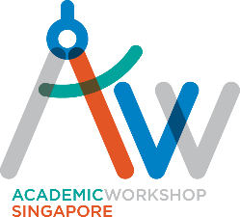

PRIMARY SCHOOL CLASSES P4, P5 and P6
PHASE 2 – REOPENING
Please take note of the following schedule for resumption of physical classes at our centre:

Tuesday P4 Session: | 30 June 2020, *2:00pm |  | Friday P5 Session: | 10 July 2020, 11.30am
Tuesday PSLE Writing: | 30 June 2020, 4:30pm |  | Saturday P6 Session: | 18 July 2020, *9:15am
Thursday P6 Session: | 2 July 2020, 3:00pm |  | Saturday P5 Session: | 18 July 2020, *11:45am
Friday PSLE Writing: | 10 July 2020, 9.30am

*Please note that some class timings have been shifted (*) to facilitate the cleaning of the classrooms in between classes and to prevent intermingling of students. This is in accordance with the guidelines stipulated by MOE. The affected classes are Tues P4, Sat P6 and Sat P5.

POLLING DAY 10th JULY – time changes. Classes will be brought forward to 9.30-11.30am and 11.30-1.30pm respectively.

Classes will remain online until the stipulated resumption dates listed above.

Updated 4 JULY 2020
Contact person: Jackie (whatsapp 98240272)
EMAIL jackie@theacademicworkshop.com

